**COMSATS University Islamabad, Abbottabad Campus**

**Department of Computer Science**

**s**

**Project Proposal**

**Readit (Learning Management System)**

**CSC392 Object Oriented Software Engineering**

Submitted on: <21-10-2022 >

Group Members:

**Group Leader:** Muhammad Umair (SP21-BSE-058)

Syed Ali Kazmi (SP21-BSE-072)

Rimsha Muneer (SP21-BSE-082)

Muhammad Saeed (SP21-BSE-071)

Shahwaiz Iqbal (SP21-BSE-061)

Abdullah (SP21-BSE-002)

Muhammad Ali Zain (SP21-BSE-065)

Haris Naeem (SP21-BSE-066)

Muhammad Uzair (SP21-BSE-059)

Table of Contents

CHAPTER 1 PROJECT PROPOSAL 3

Introduction 3

Vision and Business Case 3

Use-Case Model 4

Supplementary Specification 4

Glossary 4

Risk List & Risk Management Plan 4

CHAPTER 2 USE CASES 4

Use Case Distribution Table 4

Use Case Diagram 6

Brief Level Use Cases 6

Muhammad Saeed (SP21-BSE-071) 6

Rimsha Muneer,Ali Kazmi (SP21-BSE-082) 7

Muhammad Umair, Abdullah (SP21-BSE-058, SP21-BSE-002) 7

Shahwaiz Iqbal (SP21-BSE-061) 7

Haris Naeem (SP21-BSE-066) 7

Muhammad Ali Zain (SP21-BSE-065) 7

Muhammad Uzair,Ali kazmi (SP21-BSE-057, SP21-BSE-072) 7

Fully Dressed Use Cases 8

Muhammad Umair, Abdullah (SP21-BSE-058,SP21-BSE-002) 8

Muhammad Saeed (SP21-BSE-071) 9

Rimsha Muneer, Ali kazmi (SP21-BSE-082,SP21-BSE-072) 10

Muhammad Uzair,Ali kazmi (SP21-BSE-059, SP21-BSE-072) 12

Haris Naeem (SP21-BSE-066) 13

Muhammad Ali Zain (SP21-BSE-065) 13

Shahwaiz Iqbal (SP21-BSE-061) 13

# CHAPTER 1 PROJECT PROPOSAL

## Introduction

**Readit** is a Learning management system (LMS) written in Java. It is a Desktop application software. The Primary purpose of this is to help educational institutes, teachers, and Students. Readit LMS not only delivers content, but also handles registering courses, course administration, monitor user’s progress and performance. A learning management system provides an instructor with a way to create and deliver content, monitor student participation, and assess student performance.

The main objective of Learning Management Systems is to enhance the learning process. LMSs also include a performance management system. Educational Institutes use an LMS to teach and train students from kindergarten to graduation. Learning management systems are also used in almost all leading universities and colleges. An LMS can also be used to provide students with blended learning experiences. Blended learning combines traditional teaching in the classroom with online learning tools. This method is more effective than simple face-to-face education because it enriches the classroom-based experience with additional digital content that can be customized to fit a student's specific learning needs. They can also upload assignments and get their results very easily. This makes LMS platforms incredibly convenient for remote students who are enrolled in online courses. Learning management systems have faced a massive growth in usage due to the emphasis on remote learning during the COVID-19 pandemic.

## Vision and Business Case

Our motive behind this program is to create a LMS system which will help teachers and students to learn with the use of technology. This software will help our students understand the importance of technology as well as familiarize with it. This program will be executable at basic levels at first for instance a small portion of students but later with improvements in it, we will be able to provide it on market level. For instance, it can be used by schools as well universities.

LMS are also beneficial for corporate sector. Mostly corporate sector uses LMSes for training purposes. Other uses in corporate sector are employee development and retention. An LMS can save an organization time and money.

## Use-Case Model

1. Multi-User Account System
2. Student Attendance management
3. Daily Attendance
4. Exam Management

## Supplementary Specification

* **Security:** All usage requires authentication.
* **Visibility:**

1. Keep things simple.
2. Text should be Easily visible.
3. Follow design standards.
4. Make user interface consistent.

* **Performance:**
* **Reliability:** System will behave in user acceptable manner.

## Glossary

1.LMS, Learning Management System

## Risk List & Risk Management Plan

* No futuristic vision.
* No regular monitoring.
* Technical Limitations.
* Using tech available in labs.
* Looks static and ugly.
* Confusing for new users to navigate.
* No app for smartphones and tablets.

# CHAPTER 2 USE CASES

## Use Case Distribution Table

|  |  |  |
| --- | --- | --- |
| **ID** | **NAME** | **ASSIGNED USECASES** |
| **1** | **Muhammad Saeed** | **Login** |
| 2 | **Muhammad Haris Naeem** | **View Students** |
|  |  |  |
|  |  |  |
|  |  |  |
|  |  |  |

## Use Case Diagram

## Brief Level Use Cases

### Muhammad Saeed (SP21-BSE-071)

#### Use Case: Process Login

A user wants to interact with the system. The system prompts for username and password and user will enters his/her name and password. The system will validate the entered name and password and logs the user into the system

### Rimsha Muneer,Ali Kazmi (SP21-BSE-082)

#### Use Case: Process Assignment Management

The Use Case of assignment management system includes upload file section where students are assigned to do the task given by the teacher. Further, it includes choose file section which extends upload pdf, PowerPoint and word file in which students can select the assigned file from their system. There is another section, download file where the teachers determine the task for students and later on students ca check that against which they will upload the file. The section set due date is used by teacher inside which they set due date for the specified task and that includes other status like, pending, close, submitted and not submitted. Meanwhile, the appearance of these status depend on due date.

### Muhammad Umair, Abdullah (SP21-BSE-058, SP21-BSE-002)

#### Use Case: Process name

In this use case admin will manage the student activities, admin can add newly registered students to list. It can view and edit profile of student; it can also remove student from list.

### Shahwaiz Iqbal (SP21-BSE-061)

#### Use Case: Process manage teachers

In this use case, the admin will add and manage the teacher’s activities and records, teachers can manage courses and modules to enroll students or set up self-enrollment, and the teacher will manage the student’s progress in the study and other activities. Teachers can upload the attendance of students, upload course content, upload assignment, quiz, and exam marks of students and print the report.

### Haris Naeem (SP21-BSE-066)

#### Use Case: View Students

In this use case teacher simply view list of all students in LMS.

### Muhammad Ali Zain (SP21-BSE-065)

#### Use Case: Process name

### Muhammad Uzair,Ali kazmi (SP21-BSE-057, SP21-BSE-072)

#### Use Case: Quiz Management

In this use case the teacher will login to a website and create a quiz and enter its question and the probable answers, then the student will use their phone to login and chose the teacher and select the required quiz, then answer the questions and view the results at the end on the phone, in addition the teacher can view the quiz results on the website.

## Fully Dressed Use Cases

### Muhammad Umair, Abdullah (SP21-BSE-058,SP21-BSE-002)

| Use Case: Manage Student |
| --- |
| |  |  | | --- | --- | | **Scope** | Learning Management System | | **Level** | Admin goal | | **Primary actor** | Admin, Student | | **Stakeholder and interest** | * Student: Student will register them self-first to interact with the system for their academic activates. * Admin: Admin will have a check on the registered student profiles and their academic activities. | | **Precondition** | Student must be registered to a system and have admitted to their desire institute. | | **Success guarantee (post condition)** | With every registration, admin will receive updated list of students to system. Then admin will have check over to their profiles. | | **Main success scenario** | 1. Registered student will enroll him/her self into offered courses 2. The admin will have check into enrolled students profile, they can check their registration info, enrolled courses list, their current academic record. | | **Exception** | * When the server is down due to some reason the admin wont be able to check over the activates of student | | **Miscellaneous** | Is student is registered in their desire institute? | |

### Muhammad Saeed (SP21-BSE-071)

| Use Case: Process Login |
| --- |
| **Scope**: ReadIT (Learning Management System)  **Level**: user goal  **Primary** **Actor**: Admin, Teacher, Student  **Stakeholders and Interests**:  **Preconditions**: User must have an account with the Learning Management system i.e., he/she must be a registered user. |

**Success Guarantee** (or Postconditions): If the use case was successful, the actor is now logged into the system. If not, the system state is unchanged.

**Main Success Scenario (or Basic Flow):**

* The 'login' action is initiated when a registered user chooses to 'login'.
* The system prompts for username and password.
* The actor enters his/her name and password.
* The system validates the entered name and password and logs the actor into the system

**Extensions (or Alternative Flows):**

**1.Invalid Name/Password:**

If in the basic flow the system cannot find the name or the password is invalid, an error message is displayed. The actor can type in a new name or password or choose to cancel the operation, at which point the use case ends.

**Special Requirements:**

There are no special requirements associated with this use case.

**Open Issues:**

**Screen Shots:**

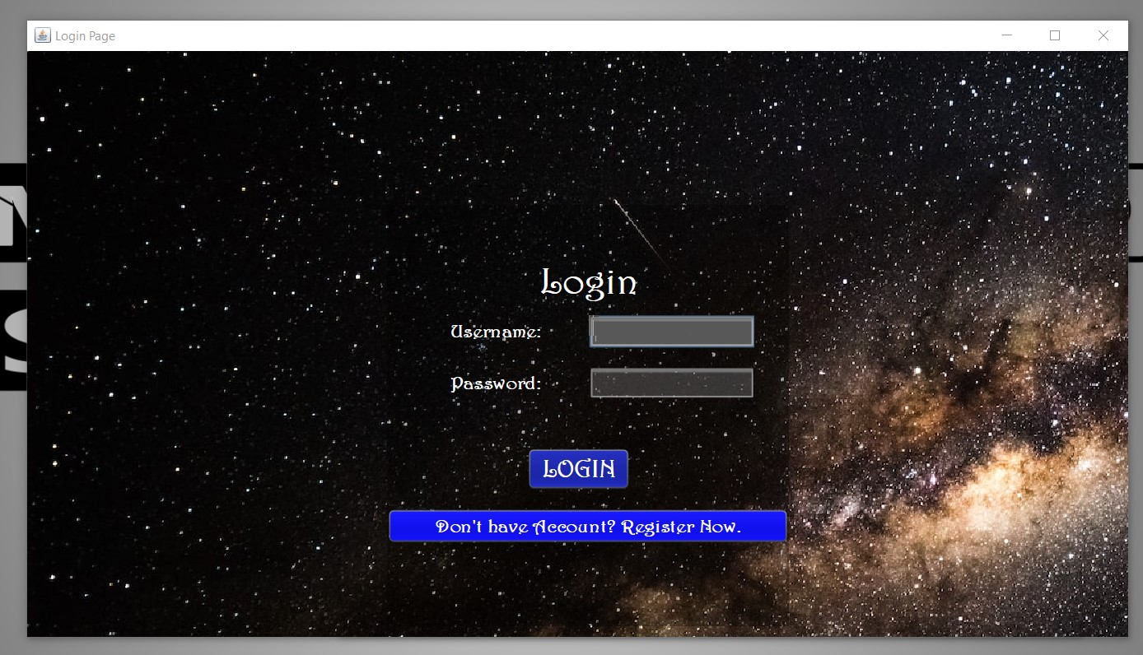

### Rimsha Muneer, Ali kazmi (SP21-BSE-082,SP21-BSE-072)

| Use Case: manage Assignments |
| --- |
| **ID:** | **07** |
| **Title:** | Manage Assignments |
| **Description:** | This use case describe how teacher assign task/assignments to students. |
| **Primary Actor:** | Teachers, Student |
| **Preconditions:** | Before uploading the assignment, teachers have to login, after selecting the subject the task is uploaded there. |
| **Postconditions:** | If the use case was successful, After the assignment is uploaded, its last date and time are shown to the student. |
| **Main  Success Scenario:** | 1. Teacher uploads task/assignment. 2. Student downloads file. 3. Submit task/assignment against given task. |
| **Extensions:** | Student can change assignment once it is uploaded. Teacher will upload marks after checking the assignment. |
| **Frequency of Use:** | Often |
| **Status:** | Elaboration Phase |
| **Priority:** | Medium |

**Screenshots:**

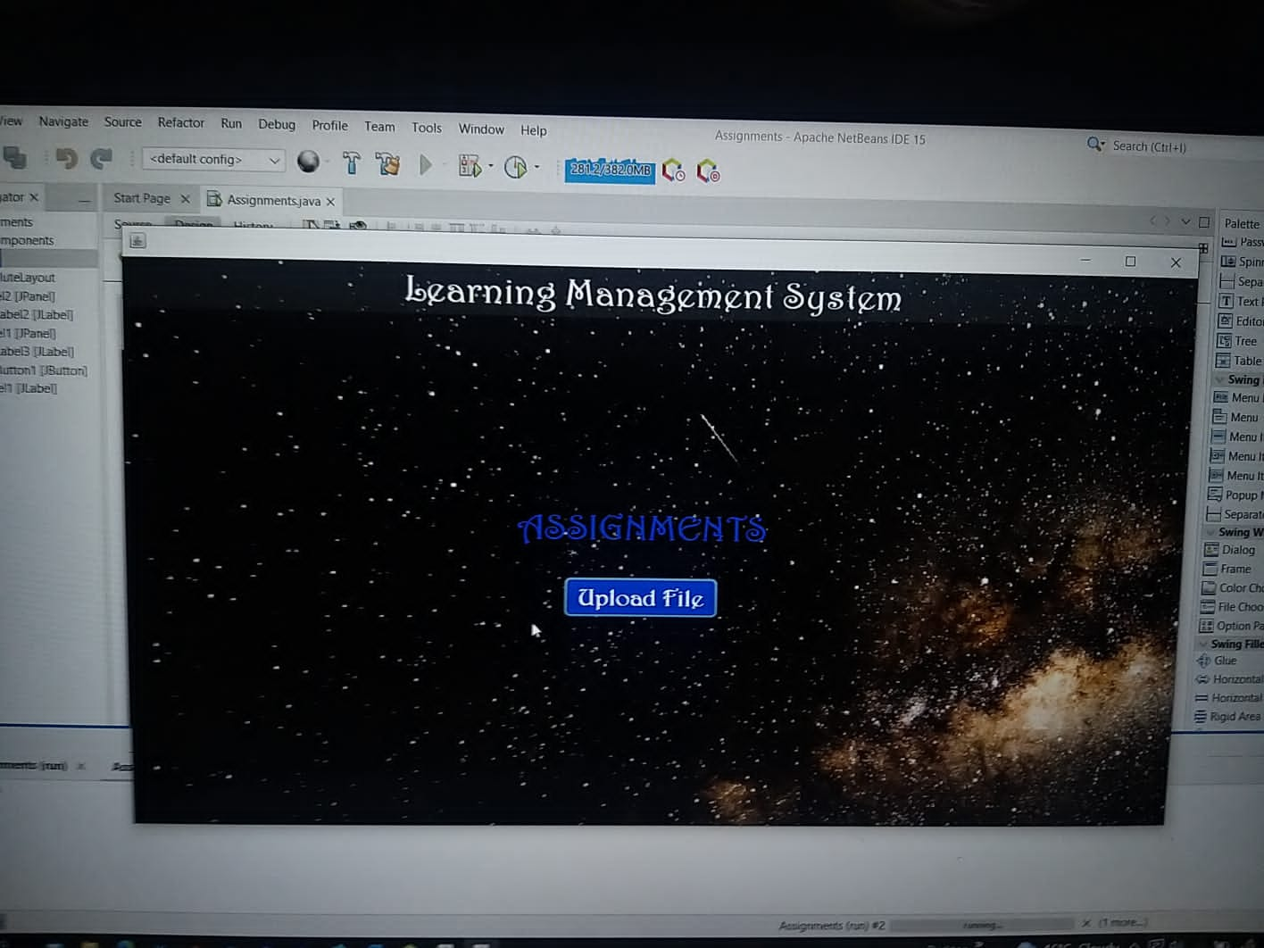

### Muhammad Uzair,Ali kazmi (SP21-BSE-059, SP21-BSE-072)

| Use Case: Process Quiz management |
| --- |

|  |  |
| --- | --- |
| Use case name | Quiz management |
| Scope | Learning management system |
| level | Student and teacher goal |
| Primary actor | * Student * Teacher |
| Stakeholder and interest | * Teacher: Teacher will upload the quiz and the checking process. * Student: Student will attempt the answers and result will be displayed. |
| precondition | * Student must have a proper internet connection. * Student must log in. * Student must start quiz on time. |
| Success guarantee | Student must complete the quiz within given time and attempt all questions correctly. |
| Main success scenario | 1. Teacher will log in with his id. 2. Teacher upload the quiz on time. 3. student will open the website. 4. Log in to his account. 5. Visit the quizzes dashboard. 6. Attempt the quiz. |
| Exception | * if student doesn’t see the quiz questions or it gets stuck, he will refresh website. * If teacher uploads the quiz and it gives error, he will try to re-upload the quiz. |
| Special requirement | Teacher and student both will have to log in  If the page doesn’t show up he must refresh the page. |
| Technology and data variation list | * Java language is used here. * Student and teacher both will require a keyboard and mouse. |
| Frequency of occurrence | This will occur at different times only when teacher wants to assess the students.  Less often. |

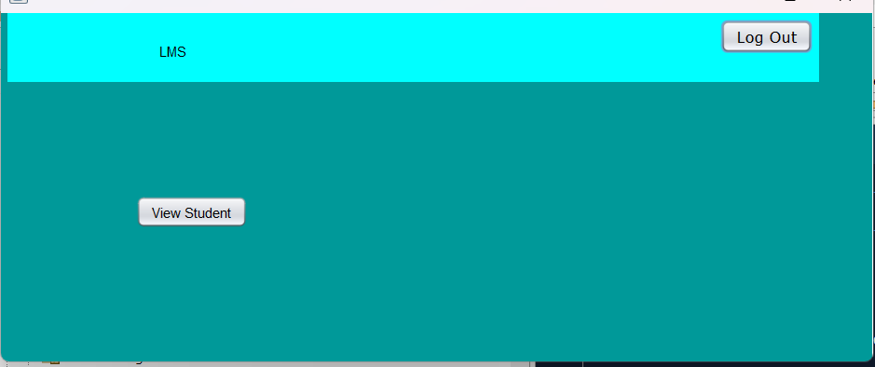

### Haris Naeem (SP21-BSE-066)

|  |  |  |  |  |  |  |  |  |  |  |  |  |  |  |  |  |  |  |  |  |  |  |  |  |  |  |  |  |  |
| --- | --- | --- | --- | --- | --- | --- | --- | --- | --- | --- | --- | --- | --- | --- | --- | --- | --- | --- | --- | --- | --- | --- | --- | --- | --- | --- | --- | --- | --- |
| Fully Dressed Use Case: View Students  |  | | --- | | View Students | | Stakeholders and Interest | Teacher, Student. | | Use Case Name | View Students. | | Scope | Learning Management System. | | Level | User goal. | | Primary Actor | Admin, Teachers. | | Stakeholders and Interests | Student, Teachers. | | Pre-conditions | Users must register itself and login in the system. | | Success Guarantee | User must watch list of students. | | Main success scenarios | User will review the list of students. | | Exceptions | If there is any glitch, then user must check their registration. | | Special Requirements | User must be registered itself and login in system. | | Technology and Data variations List | Programming language JAVA. | | Frequency of Occurrences | Often. | | Miscellaneous |  | |

### Muhammad Ali Zain (SP21-BSE-065)

| Use Case: Process name |
| --- |

### Shahwaiz Iqbal (SP21-BSE-061)

| Use Case: Process manage teachers |
| --- |

|  |  |
| --- | --- |
| **Scope** | Learning Management System |
| **Primary actor** | Admin and Teacher |
| **Precondition** | The teacher must be registered in System. |
| **Stakeholder and interest** | * **Teacher**: Teachers will register themselves first with provided ID to interact with the system for their academic activities. * **Admin**: Admin will check on the registered Teachers and student profiles and their records, performance, and academic activities. |
| **Success guarantee (postcondition)** | With every registration, the admin will receive a notification and an updated list of the Teacher in the system. Then admin will have to check over their profiles. |
| **Main success scenario** | * Registered Teachers will be provided with at least three classes in their subject. * The admin will have to check into registered teachers’ profiles, they can check their Qualification status, enrolled courses list, and previous academic record. |
| **Exception** | When the server is down due to some reason the admin will not be able to check over the activities of the Teachers. |
| **Level** | Admin Goal |
| **Special requirement** | If the feedback of the teacher about the teaching method from the side of the student is not good, then show the notification to the teacher on his portal and inform him about this scenario. |